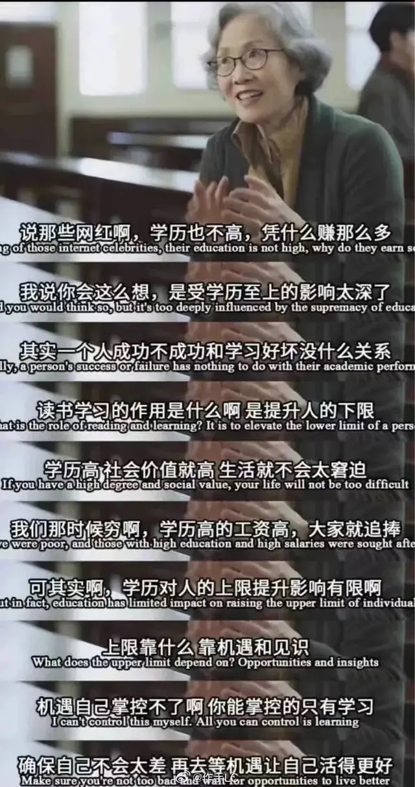

**Speaking of those Internet celebrities, their education is not high, so why do they earn so much?**

**说起那些网红，他们的学历不高，那为什么他们的收入却如此之高呢？**

**I said you would think so, but it’s too deeply influenced by the supremacy of education.**

**我说你也会这么想，是受教育至上的影响太深了。**

**Actually, a person's success or failure has nothing to do with their academic performance.**

**其实，一个人的成功与否，与学习成绩好坏没什么关系。**

**What is the role of reading and learning? It is to elevate the lower limit of a person.**

**阅读和学习的作用是什么？ 就是提升一个人的下限。**

**If you have a high degree and social value, your life will not be too difficult.**

**如果你有很高的学历和社会价值，你的生活就不会太窘迫。**

**At that time, we were poor and those with high education and high salaries were sought after by everyone.**

**那时候我们穷，学历高、工资高的人受到大家的追捧。**

**But in fact, education has a limited impact on raising the upper limit of individuals.**

**但事实上，教育对于提高个人上限的作用有限。**

**What does the upper limit depend on? Opportunities and insights.**

**上限取决于什么？ 机遇和见识。**

**I can't control this myself. All you can control is learning.**

**机遇自己掌控不了啊， 你能掌控的就是学习。**

**Make sure you're not too bad and wait for opportunities to live better.**

**确保自己不会太差，再去等待让自己活的更好的机会。**